**Schematic Diagram**

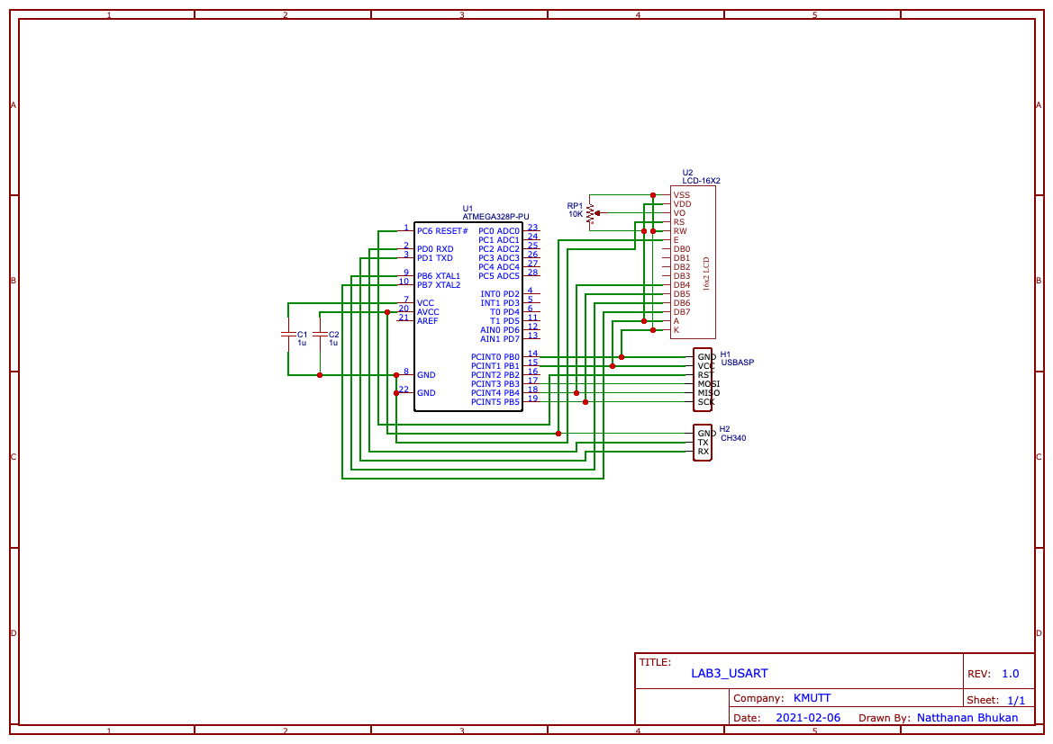

**On board**

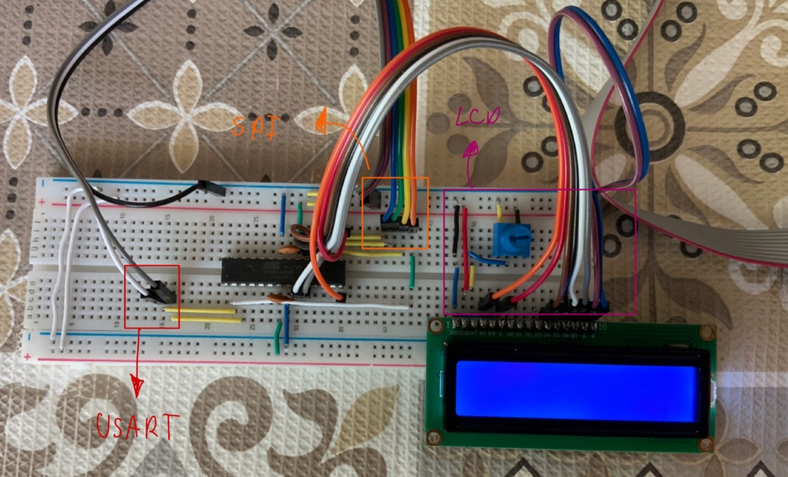

1. Write a program to receive your name from the serial port and send “Hello <your name>” back to your PC. Your program should run indefinitely i.e. you should echo “Hello ...” back for every name received.

**Code**



**Result**

1. Extend the program from the first problem to display “Hello <your name>” on the LCD screen after received name from the serial port. The message on the LCD screen should update correctly after received new name.

**Code**

**Result**

